# Project Name: myPortfolio: Easy Way to Create Your Amazing Portfolio.

## Output:

### Landing Page:



### Sign Up page:

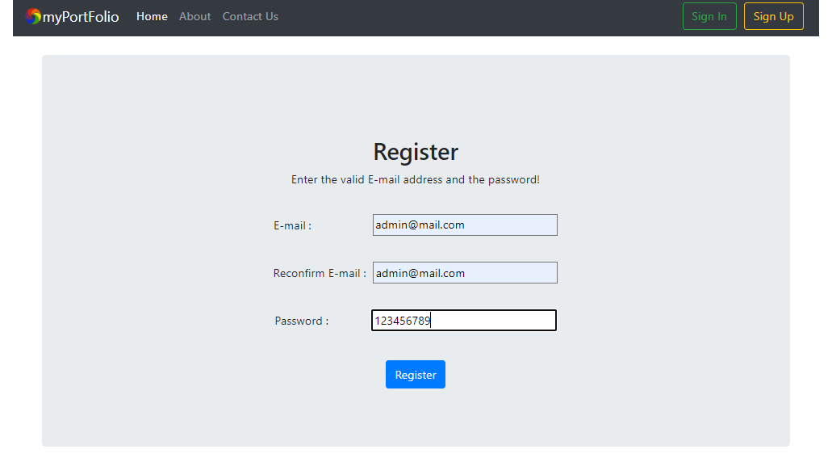

### Sign In page:

